Project Design Phase-II

Data Flow Diagram & User Stories

|  |  |
| --- | --- |
| Date | 29 October 2022 |
| Team ID | PNT2022TMID54350 |
| Project Name | Smart Waste Management System For Metropolitan Cities |
| Maximum Marks | 4 Marks |

# Data Flow Diagrams:

A Data Flow Diagram (DFD) is a traditional visual representation of the information flows within a system. A neat and clear DFD can depict the right amount of the system requirement graphically. It shows how data enters and leaves the system, what changes the information, and where data is stored.

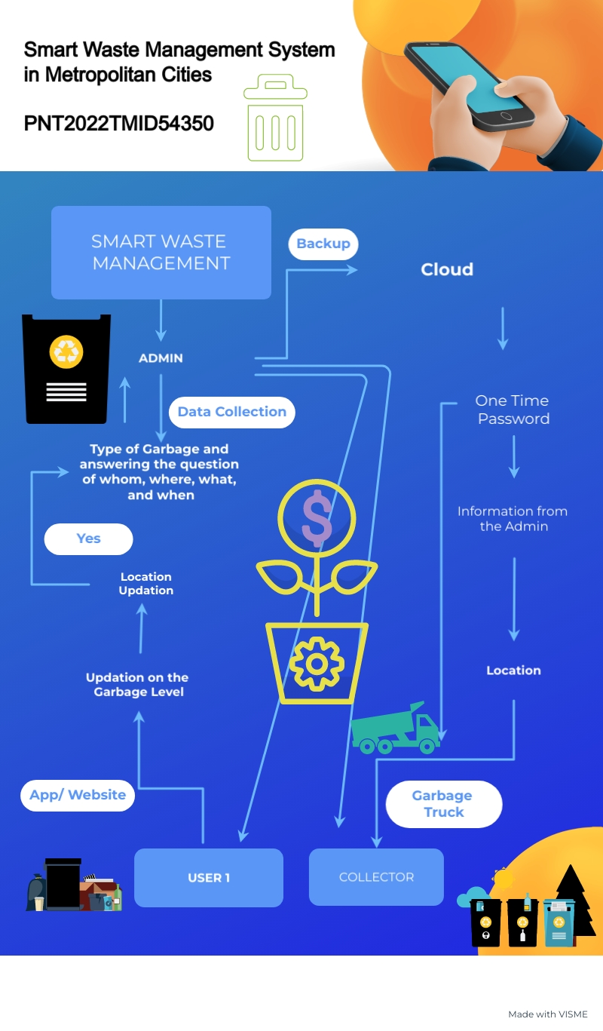

**User Stories:**

Use the below template to list all the user stories for the product.

|  |  |  |  |  |  |  |
| --- | --- | --- | --- | --- | --- | --- |
| **User Type** | **Functional Requirement (Epic)** | **User Story Number** | **User Story / Task** | **Acceptance criteria** | **Priority** | **Release** |
| **Residents (General Public User)** | Login | USN – 1 | As a Resident, I install the app, give in my information and segregate different kinds of waste in the entrance to make sure the collector takes it or notifies the collector in case of excess presence of wastes in a bin during segregation. | I segregate waste and update my app on a regular basis. | High | Sprint-1 |
| **Authorized Person** | Login | USN – 2 | As an Authorized Person, I give **user id** and **password** for every worker and manage the overall technological work. | I can access main user information and use many other management of technical and administrative part of the webpage and Web-App. | Medium | Sprint-2 |
| **(Manages** |  |  |  |  |  |  |
| **Web app)** |  |  |  |  |  |  |
| **Admin** | Login | USN - 3 | As an Admin, I will manage **garbage level monitor**. When garbage gets filling alert, I will post location and garbage Id to trash truck. | I can manage monitoring of the garbage in trash cans. | High | Sprint-1 |
| **Truck Driver** | Login | USN – 4 | As a Driver, I’ll follow the route sent by the administrator/ app that notifies the full bin to reach the filled garbage **location**. | I can manage time and reach the required destination in the shortest route. | Medium | Sprint-2 |
| **Collector Service-Man** | Login | USN – 5 | As a Collector Service Man, I’ll collect all the garbage from houses as a **door to door service man** as and load it to the vehicle where the waste segregated and send them to the required landfill. | I am able to pull a truck and collect trash. | Medium | Sprint-2 |
| **Local Authorities** | Login | USN - 6 | As a local Authoritative person, I’ll check the process and its are happening in a correct and **well-disciplined** manner. | I will be able to keep the process to run smoothly. | High | Sprint-1 |